**Online Shopping Portal and Product Recommendation**

**Abstract**— This project helps the users in curing its disease by giving the list of fruits and herbs that the user should consume to get rid of its disease. The main purpose of this project is to help the user to easily search for herbs and fruits that will be good for the health of the user depending on any health issue or disease that he/she is suffering from. This system helps the user to reduce its searching time to a great extent by allowing the user to enter its health problem and search accordingly. The admin can add fruits and herbs to the system and its information. This system also allows the user to view the selected fruit or the herb's description which describes how the fruit or the herb will help to improve the user's health. This system also allows the user to place order which will add the items to the user's cart and make payment for the same. The system also includes a module in which the user can search for the hospitals depending on the name of the disease that user enters. Thus, this system helps to get food products best suited for user health to a great extent.

System can recommend some product to the user.

**1)INTRODUCTION**

The Health Shopping Portal project needs to create the Health Shopping Portal to organize the products record and the other information about the customers. How customers can buy products from website can be recognized from their username and password. This project is an attempt to provide the advantages of online shopping to customers of a real shop. It helps buying the products in the shop anywhere through internet by using an android device. Thus, the customer will get the service of online shopping and home delivery from his favorite shop. This system can be implemented to any shop in the locality or to multinational branded shops having retail outlet chains. If shops are providing an online portal where their customers can enjoy easy shopping from anywhere, the shops will not be losing any more customers to the trending online shops such as flipcart or ebay. Since the application is available in the Smartphone it is easily accessible and always available.

**Class Diagrams:**

**Version 1**

**Version 2**



**Version 3**

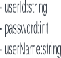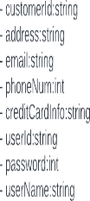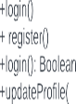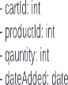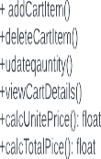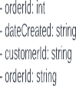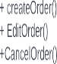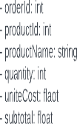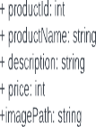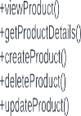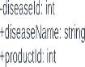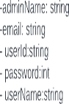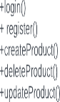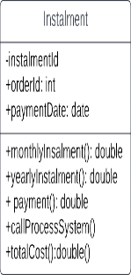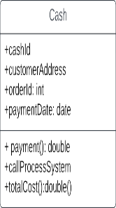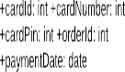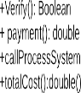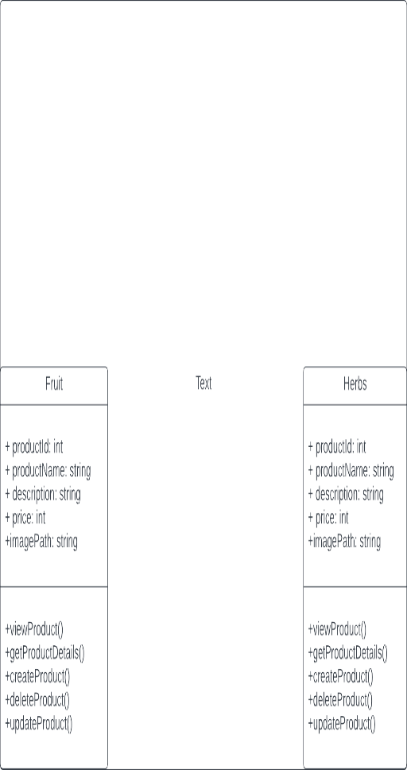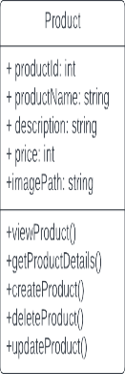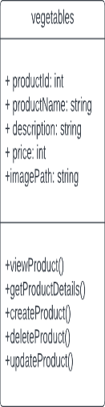

**Sequence Diagrams:**

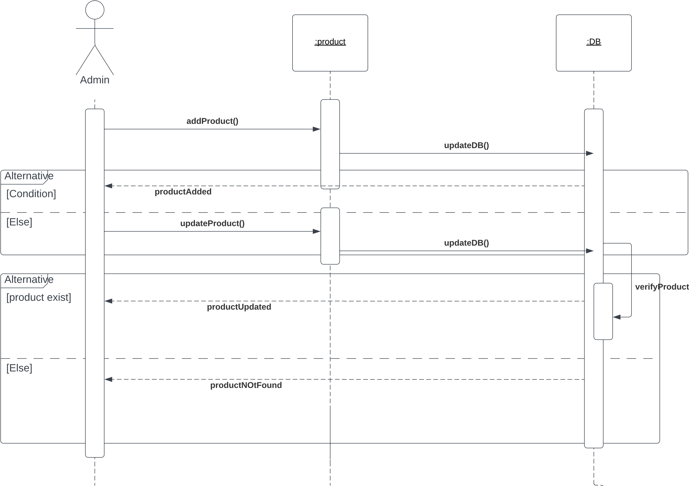

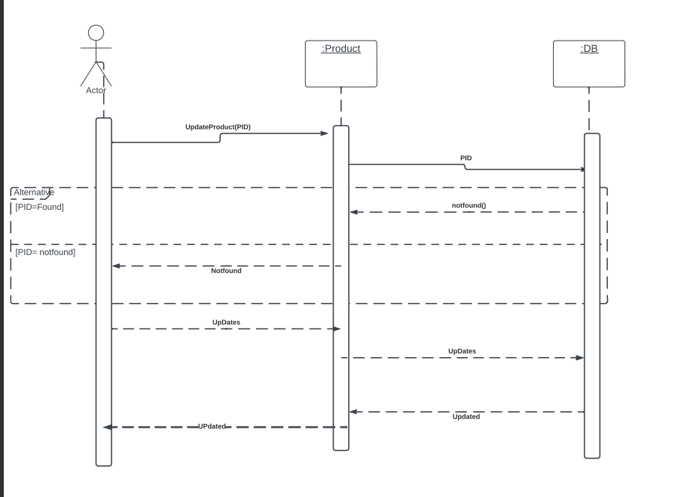

**Use Case**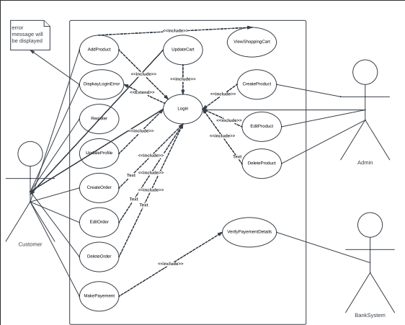



|  |  |
| --- | --- |
| Use case name | AddProduct |
| Description | This method enables the admin to add new products to the system after inserting  The details |
| Scenarios | Main success scenario: the Admin enters the details of the new product he wants to add and the product is added successfully  Unsuccessful scenario: the admin fails to add the new item maybe because the item is already existed in the system |
| Pre-conditions | The admin has to login to the system before he add the product |
| Post -conditions | The product should be added to the system with its details |
| Steps | -The user(customer or Admin) enters his user name and password  - the user press sign in  -The verifyLogin() method is called when the user clicks the "Sign In" button .It returns true if the login is successful, false if it is not. |

|  |  |
| --- | --- |
| Use case name | Login |
| Description | The user (customer or admin) should login to the system through this method |
| Scenarios | Main success scenario: the user logs in to the system after he enters his username and password correctly  Unsuccessful scenario: the user enters one of the two inputs wrong or the system crashes so he is unable to login to the system |
| Pre-conditions | The user should have a valid username and password |
| Post -conditions | The user should be logged into the system |
| Steps | -The user(customer or Admin) enters his user name and password  - the user press log in button  -The verifyLogin() method is called when the user clicks the "Sign In" button .It returns true if the login is successful, false if it is not. |

|  |  |
| --- | --- |
| Use case name | MakePayment |
| Description | The customer is able make payment for his products through this method  With the suitable way |
| Scenarios | Main success scenario: the customer enters his card details and these details are verified successfully and the payment method is done  Unsuccessful scenario: the user enters one of the two inputs wrong or he has no enough credit in his account |
| Pre-conditions | The user should have an active account and enough credit to cover the order cost |
| Post -conditions | The customer should be informed with all the delivery details |
| Steps | -The customer enters his credit card details  -The verifyLogin() method is called when the user clicks the "Sign In" button .It returns true if the login is successful, false if it is not. |